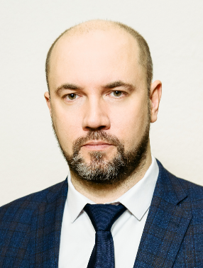

Ulrich Dmitry Vladimirovich

Dean of the Faculty of Environmental Engineering and Municipal Services of the SPbGASU , Saint Petersburg, RF

**Education**

Speciality- Agroecology

Qualification- Scientist agronomist-ecologist (Chelyabinsk State Agroengineering University, 2005)  
Direction of training-Water supply for cities and industrial buildings

Qualification-Master of Engineering (Southwestern State University, 2013)

**Advanced training (training)**

**Occupational safety training and testing of knowledge of occupational safety requirements**

* Occupational safety in higher education institutions (10/31/2023–11/10/2023/40/SPbGASU)
* General issues of labor protection and functioning of the labor protection management system (2023/16/SPbGASU)
* Safe methods and techniques for performing work when exposed to harmful and hazardous production factors, sources of danger identified within the framework of the special assessment of working conditions and assessment of professional risks (2023/16/SPbGASU)
* Providing first aid to victims (2023/8/SPbGASU)

**By profile of teaching activity**

* Anti-corruption in higher education (22.11.2021–19.12.2021/16/Southwestern State University)

**Professional interests**

* Scientific research in the field of purification of natural and waste waters
* Educational and methodological developments
* Publishing activities

**Scientific interests**

* Development of technologies for purification of industrial wastewater, surface runoff using bioengineering structures, sorbents and highly effective natural materials

**Participation in scientific conferences**

Participant of more than 30 scientific conferences.

**Participation in the work of the Russian Academy of Sciences and/or scientific and public organizations**

* Advisor RAASN

**Number of publications**

Author of more than 150 published scientific and educational works.